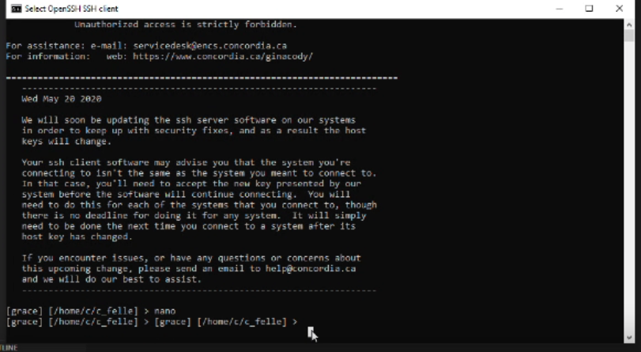

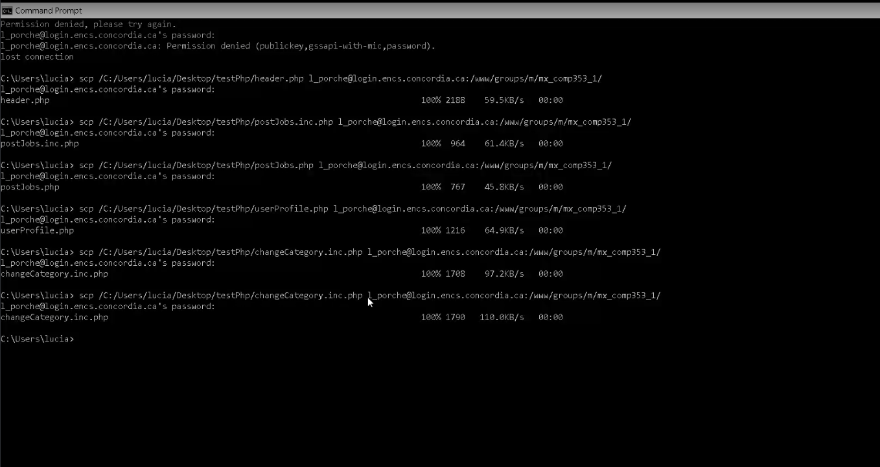

scp /C:/xampp/htdocs/rootFolder/currentApplication.php y_yifan@login.encs.concordia.ca:/www/groups/m/mx_comp353_1/

//直接用

/www/groups/m/mx_comp353_1

[19:05]

ssh -L 12000:mxc353.encs.concordia.ca:3306 y_yifan@login.encs.concordia.ca

scp /the/path/to/your/local/file

username@login.encs.concordia.ca:/www/groups/m/mx_comp353_1/

[17:22]

scp -r y_yifan@login.encs.concordia.ca:/www/groups/m/mx_comp353_1/ /Users/pasha/Downloads/Uni/COMP353/Main\ Project

this is the command scp /the/path/to/your/local/file [y_yifan@login.encs.concordia.ca:/www/groups/m/mx_comp353_1/](mailto:y_yifan@login.encs.concordia.ca:/www/groups/m/mx_comp353_1/)

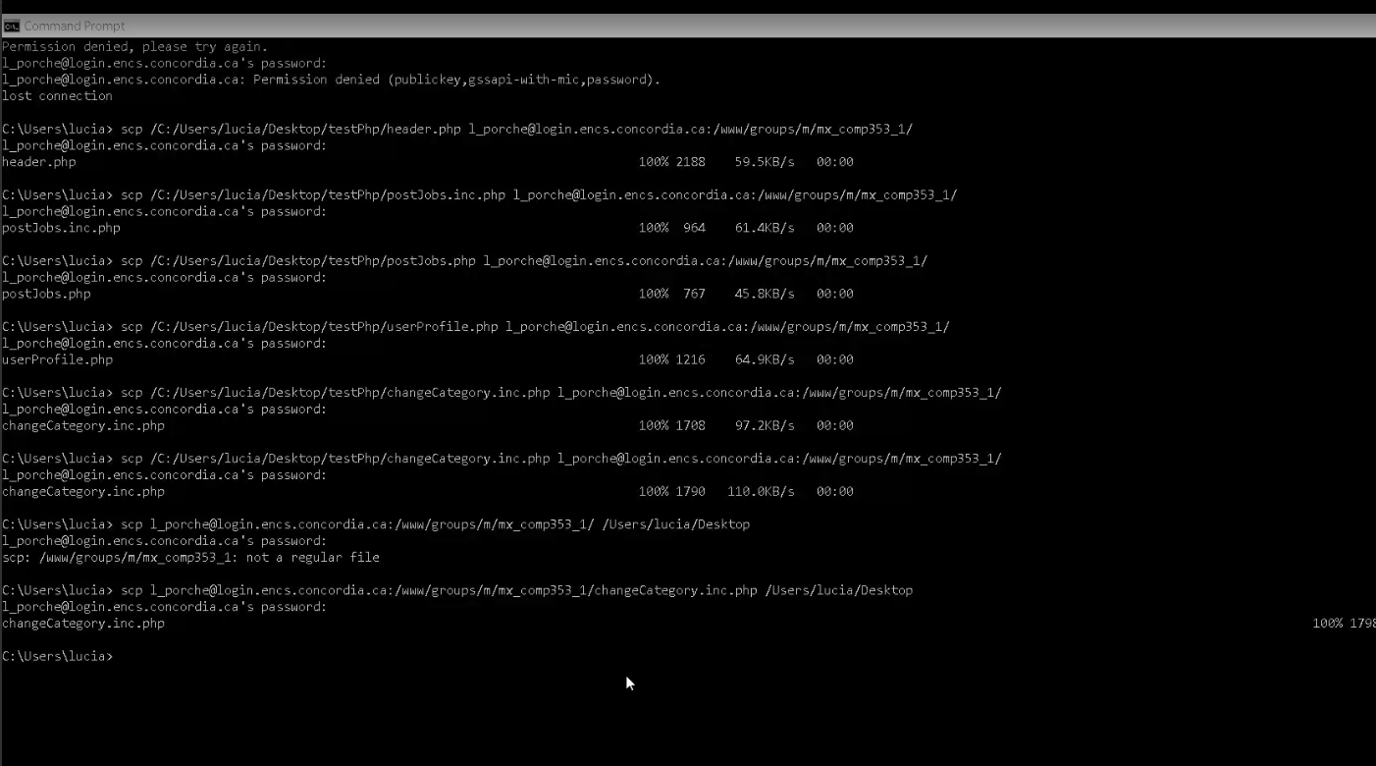

Should be able to see a summary of current application at a glance.

先用这个登录

ssh -L 12000:mxc353.encs.concordia.ca:3306 [y_yifan@login.encs.concordia.ca](mailto:y_yifan@login.encs.concordia.ca)

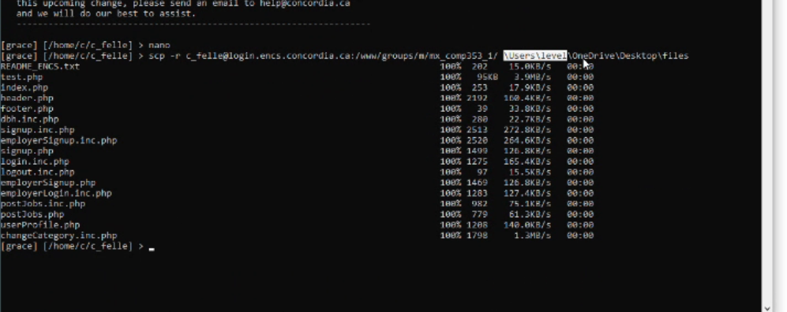

scp -r y_yifan@login.encs.concordia.ca:/www/groups/m/mx_comp353_1/ \Users\Administrator\temp //直接用